

Functional Requirements Document

Version | Description of Change | Author | Date
1.01 | Implementation of New Solution | Michael Acheampong, Alea Cobham, Ammanuel Larebo, Natsai Ndebele, Kenneth Okoye,Marcus Williams | 11/20/2016

INTRODUCTION
Exebeatz is a Java based Exercise App, that allows users to workout anywhere. Unlike most exercise apps, this app’s exercises are accompanied with music to motivate the user. In addition, the app allows the user to select either a full body workout, or to target a specific target area then from there on the user can work out. The app also calculates the user’s Body Mass Index, and allows the user to store their information which is stored on a database. Upon logging onto the system the user can then experience all the features of the app. Such as workouts of their choice which are accompanied with detailed instructions of how to correctly do the workouts, secondly animations thoroughly demonstrating how to do the workout. The user can also set the duration of how long they want to work out for, within the app, and they can also decide when to move onto the next exercise.

Purpose
The main purpose of Exebeatz, is to provide user a unique workout experience that infuses music, and allows the user to select what type of workout they want to achieve.

Scope
Objectives:
- Allow new users to create a profile
- Store User details on a database
- Allow users to login
- Create a Grid that allows users to select workouts using a Graphical User Interface
- Have workouts that run on a timer
- Have animations within workouts
- Have music play during workouts
- Have a detailed description of workouts during the workout
- Use a Stack to plan workouts

References
Timeline:
Tasks | Method | Start Date | Duration in Days | End Date
First Group Meeting/Feasibility Study | We met as a group and came up with some solutions that we could do. We came up with four solutions, a lyrics finding app, a dating app, exercise app and a Birthday App. From here on we all decided to take a week to go and research about which app would fit us best | 10/24/2016 | 7 | 10/31/2016
Meeting | After conducting a Feasibility Study, we then all met a week later, and we all came to the conclusion that we wanted to do an exercise app. This was due to the fact because this would be an app that we all had a vested interest in. | 10/31/2016 | 1 | 10/31/2016
Investigation and Analysis | Conduct online research to investigate what type of exercises we need to include. | 11/02/2016 | 2 | 11/4/2016
 | Identifying what roles each team member would play | 11/02/2016 | 1 | 11/2/2016
 | Picking roles for each team member | 11/03/2016 | 1 | 11/03/2016
Meeting/ Design | Draw sketches for tables. | 11/04/2016 | 1 | 11/04/2016
 | Draw sketches for the design of the relationships to the for the table structures | 11/04/2016 | 1 | 11/04/2016
 | Draw flowchart diagrams to explain what happens to the data as it flows thought the system. | 11/04/2016 | 1 | 11/04/2016
 | Identifying data structures to be used | 11/04/2016 | 5 | 11/09/2016
Developing/Programming | Designing the user interfaces and Data structures | 11/10/2016 | 17 | 11/27/2016
Meeting | Checking how the project was coming up and working on redesigning some features | 11/14/2016 | 1 | 11/14/2016
Meeting | Met to review project and | 11/21/2016 | 1 | 11/21/2016
 | The testing of certain parts of the program was also done. Corrections were made to the errors | 11/21/2016 | 5 | 11/26/2016
Meeting | Met to work on the workout selection grid | 11/22/2016 | 1 | 11/22/2016
Meeting | Met of work on the GUI, for the Workout class | 11/23/2016 | 1 | 11/23/2016
Virtual Meeting | Met to continue the development of the project | 11/25/2016 | 1 | 11/25/2016
Virtual Meeting/ testing | We met online to make final touches to the project and also work on the database link. | 11/26/2016 | 1 | 11/26/2016
Implementation | Documents put together and user manual and deployment document made | 11/25/2016 | 3 | 11/28/2016
References:
Exercise instructions from: popsugar.com and 30dayfitnesschallenge.com

Assumptions and Constraints
- Technical Platform
- Full detailed scope of project produced

Assumptions
Technical Platform:
One assumption that was made during the creation of exebeatz is that the user would have access to a computer, because the app would be run as a desktop app.

Constraints
- One constraint that we had was being able to produce a fully detailed project as we had hoped. This is due to the limited time we had to complete a full scaled project. As a result this is the first draft of what could be a larger scale project.

METHODOLOGY

FUNCTIONAL REQUIREMENTS

Context
Exhibit 2 - Generic Context Diagram
Data 6
Data 1
Data 3
Data 4
Data 7
Data 2
Data 8
Exebeatz
Backend
Developers
GUI
Client
GUI
Client 1
(User)
GUI
Client
Data 5
Above is the context diagram of the system. It shows the parties and how they will interact with the system.
User:
The system user will only interact with the front end of the system which involves the graphical user of the system. All data input will come from the users who will input their details to create a profile, and enter their details to log into the system.
Client:
The client is also allowed access to the front end of the system, and the code base in case they would like to view anything on the front end of the system. They also have access to the backend of the system where they have access to the database and the codebase. From here they could add any feature updates of make any minor corrections that could be done by an in-house developer.
Back-end Developers:
The back-end developers have access to the back end of the system. They can make any major changes to the system, and they can make changes to the code base.

Data Flow Diagrams
Systems Flowchart Diagram:
User Inputs their details
Data entered is validated to ensure that the correct data is entered
Display an error message if incorrect data is entered
User details stored in the Profile table
Databases updated
User logs into the system using
Username and password

Once logged in the user selects their work out for the day

Work out details are stored in the workout archive to store the user’s progress
The system outputs the User’s workout

System Flow Charts:
User Inputs Name, Username, Weight, Height, Gender
Is data entered correct?
Yes
No
Create the Account Details and the User account details will be saved in the profile table
Start
Stop
When a new user creates a profile, the details are first checked, and if incorrect details are entered then the system will refresh the pag so the user can enter their details again. From then on the details are stored on the Profile table in the database.
Enter weight and height on the Create Account form
Is data entered correct?
Yes
No
BMI displayed and updated in the Profile table
Start
Stop
This part of the form is used to calculate the Body Mass Index of the user using the user’s heigh and weight. This is stored in the Profile table with the other profile details of the user.
Enter username and password
Is data entered correct?
Yes
No
User is logged into the system and taken to the Workout Selection page
Start
Stop
Error message displayed, and user asked to enter correct username and password
The user login page is used by the user to log into the system. When the user enters their username and password. This is compared to the usernames and passwords in the Profile table, and if a match is found the user is logged into the system. If no match is found an error message is displayed and the user has to re-enter their username and password again.

Functional Requirements
Link to database to store data in the user Profile table:
This is the first functional requirement for the application. When the user creates a new profile in the New User Form, the new records are updated in the Profile table. The user is given a unique key ID, is created in the Profile table
Allow Users to Log into System:
The system should be able to allow the user to log into the system. When the user enters their username and password the details should be compared to details in the Profile table, if the details do not match and error message should be returned.
Allow user to calculate their BMI:
When the user inputs their weight and height the system calculates the user’s BMI using a formula to calculate BMI.
The system will use a Stack:
The system will use a stack to push GIFs and texts onto the workout page. When a workout type is selected, the first workout on the queue is pushed onto the stack. The Gif and the Text describing the workout are pushed on. When the workout is completed, the workout GIF and text are pushed out of the stack, then the next workout is popped out after it is completed. This process is repeated until all workouts are done.

Functional Requirements Group 1

Exhibit 4 - Sample Requirements Group 1
Section/ Requirement ID | Requirement Definition
FR1.0. | The system shall [Creation of New User Profile].
FR1.1 | The system shall [New User Login].
FR1.1.1 | The system shall [Calculate BMI].
FR1.1.2 | The system shall [Use a Stack to change workouts].

Functional Requirements Group 2
Allow user to select a workout:
The app will have a workout selection page that allows the users to select the type of workout they would like to do. The workouts will be sorted according to target areas.

Timer to time workouts:
The app should allow the user to enter how long they would like to do the workout. Once the user has entered their workout duration, the timer begins to count down. Once the timer reaches 0, it changes to the next workout.

Play music during the workouts:
The app has a music feature, which means that when users start a workout. A song begins to play. They also will have the option to stop the music whenever they want to.

Interface Requirements
Use of Buttons to Navigate through the System
In order for the users to easily navigate through the system the system will have buttons, which can be programmed using Java’s Graphical User Interface.

GUI interface Grid to allow users to select workout
The workout selection page will use a Graphical User Interface Grid which allows them to select a workout target area and workout.

Display Animation of the workout
The workout forms should display an animation of the exercise that the user is doing to serve as a demonstration for the user as they workout.

Display Text describing the workout
The workout forms should also display the instructions of how to do the workout in the form of text.

Software Interfaces
The system will run using a Graphical User Interface, which will allow users to easily navigate through the system using a mouse.

Communications Interfaces
The application will communicate with the MySQL database, in order to store data within the profile table. A JDBC driver (MySQL Connector) will be used to connect the database and java files.

Hardware/Software Requirements
In order to use the System, the user will need to have the following
- CPU
- A monitor screen to display the workouts
- A keyboard for the user to be able to input data into the system
- A mouse to enable the user to easily navigate through the system

Operating Systems: Linux, Windows, IOS

Security and Privacy
- Loss or corruption of data
The loss and corruption of data within this system would result in the loss of all user details. The user details stored in this system would have to be re-entered by the user if lost.
- Disclosure of secrets or sensitive information
An agreement will be signed by all back-end parties involved not to disclose any sensitive information to any other parties. The nature of the data we will handle is not too sensitive, however user privacy will still be upheld.
- Disclosure of privileged/privacy information about individuals
No information about users will be disclosed to any third parties. Back end users who are qualified administrative staff will be able to see the data.
- Access by user role or types.
The backend users of the system which are the developers have access to the backend and front end of the system. This includes the MYSQL database and Java codebase.
The front end users of the system which are the clients will have access to the front end of the system.

Recoverability
A. In the event the application is unavailable to users (down) because of a system failure, how soon after the failure is detected must function be restored?
B. In the event the database is corrupted, to what level of currency must it be restored? For example “The database must be capable of being restored to its condition of no more than 1 hour before the corruption occurred”.
C. If the processing site (hardware, data, and onsite backup) is destroyed, how soon must the application be able to be restored?]

System Availability
The application is available to users at all times, to any users that have the application installed, on the correct hardware and software.

Data Retention
The user data will be kept in the system as long as the user is still an active member of the system (active in the past 6 months). From then on to avoid data redundancy their profile will be deleted.

Validation and Verification Rules
Description: Verifies if one or more new user input fields are empty
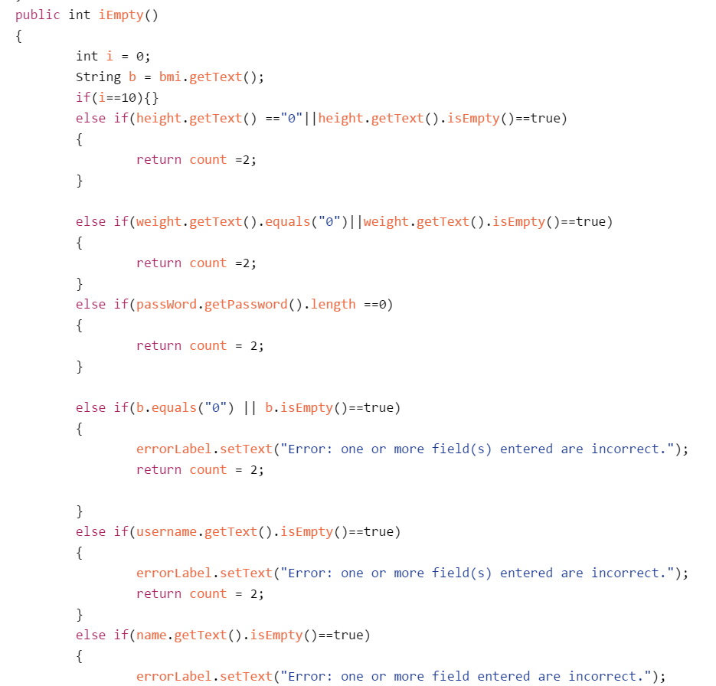
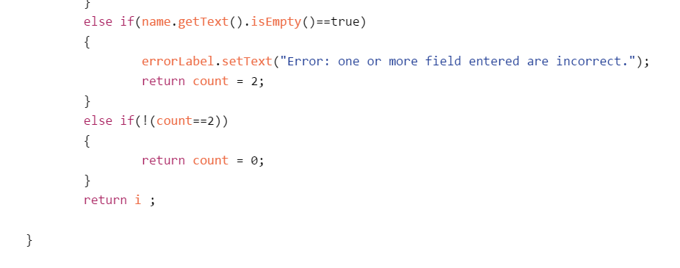
Description: Verifies single excersize workout completion
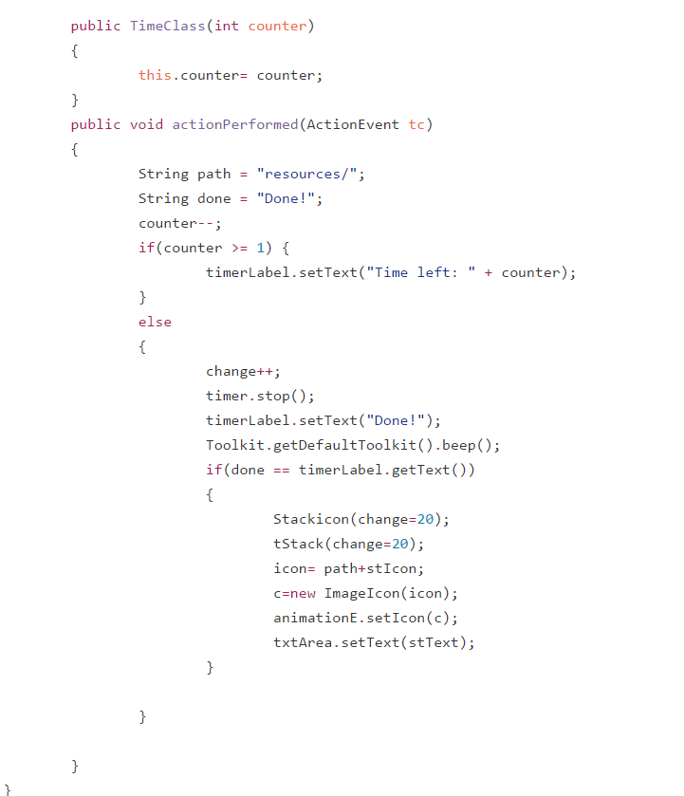
Description: Verifies if sountrack can be stopped
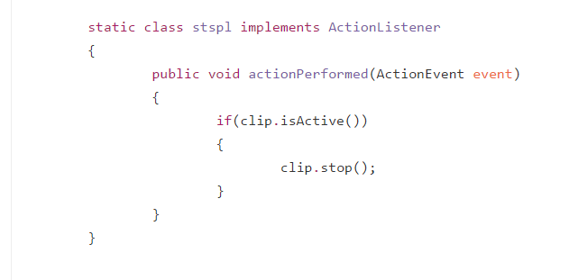

Description: Veries workout section completion
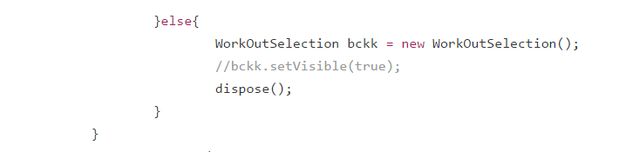
Description: Verifies Body Mass Index
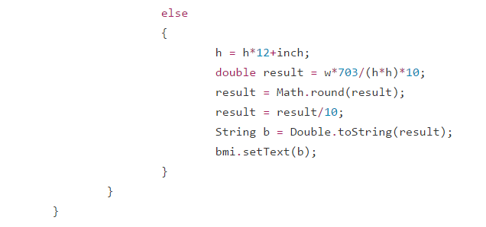
Description: Veriefies if Username and Password don’t match

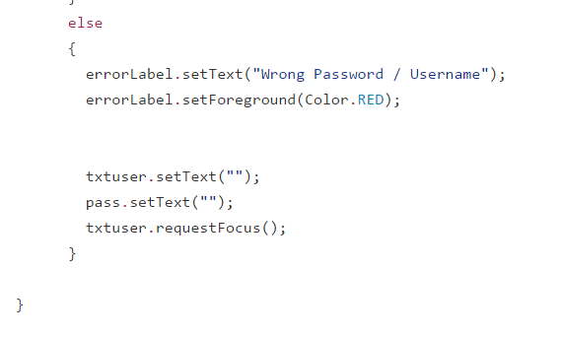
Description: Verifies if user can exit app from workout
